Docker -Maven Project:

Search Maven-Java-Project from Git ,Fork and Clone

Do upto Jenkins. (Instakk JAVA,GIT,MAVEN,JENKINS)

Jenkins File -Pipeline script
pipeline {
agent any
stages {
stage('CodeCheckout') {
steps {
script {
checkout scm
def mvnHome = tool 'maven-3'
def javaHome = tool 'JAVA_1.8'
}
}
}

stage('build customer app code') {
steps {
script {
def mvnHome = tool 'maven-3'
def javaHome = tool 'JAVA_1.8'
sh 'mvn clean install'
}
}
}
stage ('Functional Testing'){
steps {
script {
echo "Functional Testing"
}
}
}

stage ('User Acceptance Testing'){
steps {
script {
echo "User Acceptance Testing"
}
}
}
}
}

create Dockerfile and paste the below code:
FROM openjdk:8-jdk-alpine
WORKDIR /usr/src/app
COPY . .
EXPOSE 3001
CMD java -jar /usr/src/app/target/maven-java-project-1.0-SNAPSHOT.jar

Go to project folder : cd Maven-Java-Project/

ls
212 sudo yum install -y get maven
213 mvn package
To make build for Maven (Jar file),run above command
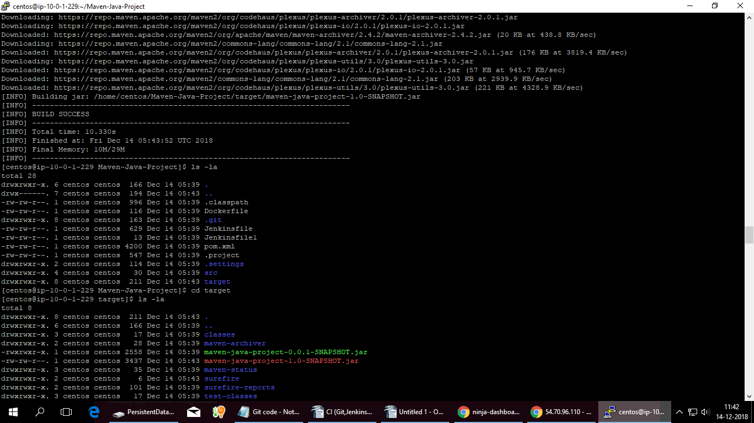
214 ls -la
215 cd target
216 ls -la
217 cd ../
218 ls -lrt
219 cat Dockerfile
220 vi Dockerfile
221 ls -lrt
222 cd target/
223 ls -lrt
224 vi ../Dockerfile
225 cat Doc
226 cat ../
227 cat Do
228 cd ../
229 ls -lrt
230 cat Dockerfile

231 sudo docker build -t ayyappanpads/helloipan .
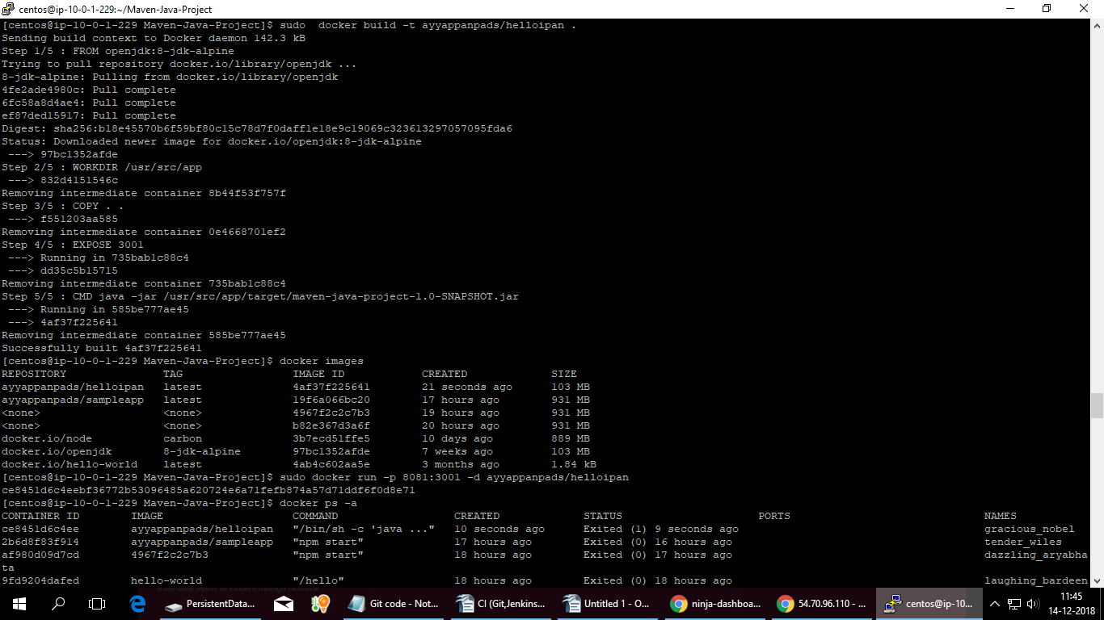
232 docker images
233 sudo docker run -p 8081:3001 -d ayyappanpads/helloipan
234 docker ps -a
235 docker ps
236 sudo docker run -p 8081:3001 ayyappanpads/helloipan
237 sudo docker run -p 3001:8081 -d ayyappanpads/helloipan
238 docker ps
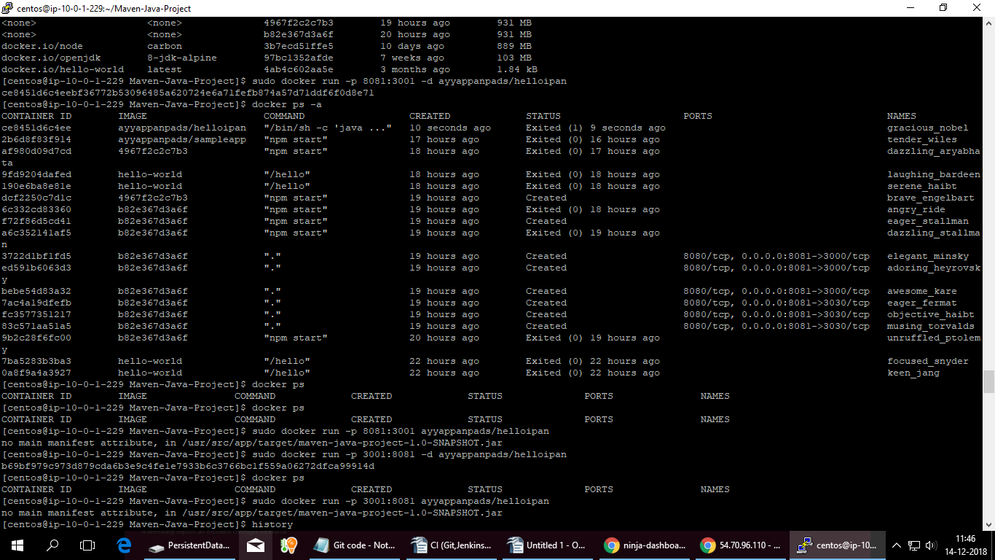
239 sudo docker run -p 3001:8081 ayyappanpads/helloipan

Login into the container : docker exec -it 47887dbc7c81 bash

Dockor on Docker
Srini will give doc.

Kubernetes or Docker Swarms

Container Orchestration

Master Node
1) API Server-Cluster management-Master-Worknode
2) Controller-Diff type of controller
3) Schedular-Distributing workload to worker node
4) etc-storing config object

Doctor Engine should be installed in slave

Workernode
- kubecites
- kubeproxy
- pods

Kops-Kubernetes Operations

1) Install kubelet
- Install Kops
- Install AWS CLI
- Configure AWS CLI
- Public Domain or Sub Domain
- Register in Route53 server-AWS
- Create Bucket-Store all config and cluster config
- Instance create in master
- worker node created in master
- Type of master and slave ,no of slave nodes.

